# Lab 6 Data Digitron

**Part 1**

What to do in lab report

Explain why the red and green LEDS never light up simultaneously.

**Part 2**

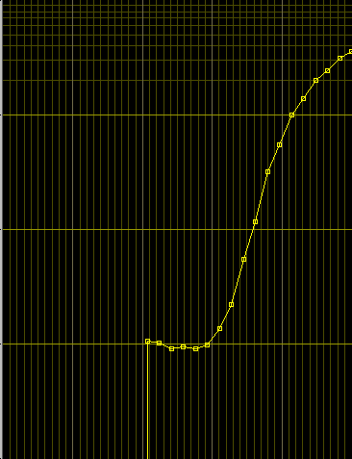



Graph 2

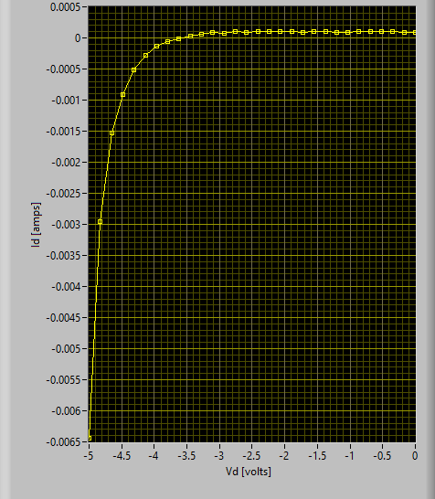

Graph 2 data



**What to do in lab report**

Show all screen shots.

Using the data file saved above, estimate the voltage difference between two points of 10x current difference in the linear region when the current axis uses log scale. Compare your result with the 60 mV per decade rule.

For example, use approximate current values of 5 mA, .5 mA or .6 mA, .06 mA to test the rule. If you cannot find two current values in the linear region that are approximately a decade apart, linear interpolation will be required. Compare the corresponding voltage differences with 60 mV. A graph made using data from this measurement is shown in [Figure 8](http://www.eng.auburn.edu/~niuguof/2210labdev/html/diode.html#fig-slopeofdiodeiv) and illustrates a 72 mV/decade slope. Note that a log scale is used for the current axis to facilitate observation of the voltage swing required for a 10x change of current.

**Part 3**